Academic Calendar – Session 2023-2024
FOR UNDER-GRADUATE COURSES
(ODD SEMESTER)
Admissions 01.07.2023 to onward
Teaching Term 20.07.2023 to 24.11.2023
Examination 25.11.2023 to 22.12.2023
Break 21.12.2023 to 31.12.2023
(EVEN SEMESTER)
Teaching Term 01.01.2024 to 30.04.2024
Examinations 01.05.2024 onward
Summer Vacations 25.05.2024 to 30.06.2024
FOR POST-GRADUATE COURSES
(ODD SEMESTER)
Admissions 01.07.2023 to onward
Teaching Term 20.07.2023 to 24.11.2023
Examination 25.11.2023 to 22.12.2023
Break 21.12.2023 to 31.12.2023
(EVEN SEMESTER)
Teaching Term 01.01.2024 to 30.04.2024
Examinations 01.05.2024 onward
Summer Vacations 25.05.2024 to 30.06.2024
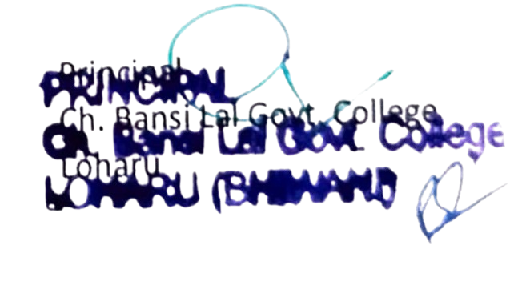

Academic Calendar – Session 2023-24
(ODD SEMESTER)
Class Test I 25.09.2023 to 30.09.2023
Class Test II 16.10.2023 to 25.10.2023
Assignment 01.11.2023 to 11.11.2023
(EVEN SEMESTER)
Class Test I 18.03.2024 to 23.03.2024
Class Test II 01.04.2024 to 06.04.2024
Assignment 22.04.2024 to 27.04.2024
(The Academic Session will start from 20.07.2023 for both U.G. & P.G. Courses)
Note: If the number of teaching days falls less than 180 days (90 days in each semester) in the academic session 2023-24 due to some unforeseen reasons, the teachers will ensure that the shortage is made good by arranging extra classes.

