It is informed that Vice-Chancellor is pleased to approve the Common schedule of Academic Calendar for Undergraduate and Postgraduate programmes for the Teaching Departments of the Colleges for the Session 2024-25 is as under:

Academic Calendar – Session 2024-2025
FOR UNDER-GRADUATE COURSES
(ODD SEMESTER)
Admissions 10.06.2024 on wards
1st Teaching Term 22.07.2024 to 26.10.2024
Vacation (Diwali) 27.10.2024 to 03.11.2024
2nd Teaching Term 04.11.2024to22.11.2024
Examination 23.11.2024 on wards
Break ( Winter) 21.12.2024 to 31.12.2024
(EVEN SEMESTER)
1"tTeaching Term 01.01.2025 to.08.03.2025
Break (Holi) 09.03.2025 to 16.03.2025
2^{n}d Teaching Term 17.03.2025 to 30.04.2025
Examinations 01.05.2025 on wards
Summer Vacations 20.05.2025 to 30.06.2025
FOR POST-GRADUATE COURSES
Admissions 13.06.2024 on wards
1st Teaching Term 01.08.2024 to 26.10.2024
Vacation (Diwali) 27.10.2024 to 03.11.2024
2nd Teaching Term 04.11.2024 to 30.11.2024
Examination 02.12.2024 on wards
Break ( Winter) 21.12.2024 to 31.12.2024
(EVEN SEMESTER)
1"tTeaching Term 01.01.2025 to.08.03.2025
Break (Holi) 09.03.2025 to 16.03.2025
2^{n}d Teaching Term 17.03.2025 to 30.04.2025
Examinations 01.05.2025 on wards
Summer Vacations 20.05.2025 to 30.06.2025
(The Academic Session will start from 10.06.2024 for both U.G. and from 13.06.2024 for P.G. Courses)
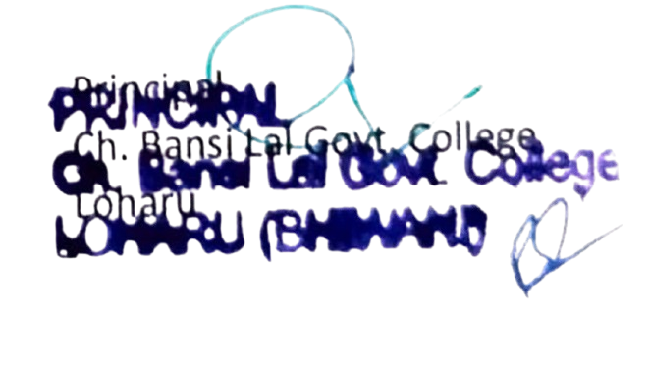
Note: If the number of teaching days falls less than 180 days (90 days in each semester) in the academic session 2023-24 due to some unforeseen reasons, the teachers will ensure that the shortage is made good by arranging extra classes.

